## SWARM ROBOT

Submitted in partial fulfillment of the requirements

of the degree of

Bachelor Of Engineering

by

Pratik Waghmode 67

Sanskar Halpati 17

Vedant Hatte 18

Ishan Udgirkar 60

Prof. N. Gopalakrishnan Sir



# Instrumentation Engineering

Vivekanand Education Society's Institute of technology

(2022-23)

##### CERTIFICATE

This is to certify that the project entitled **“ Swarm Robot ”** is a bonafide work of **“Pratik Waghmode (67); Sanskar Halp**a**ti(17); Vedant Hatte(18); Ishan Udgirkar(60)”**. submitted to the University of Mumbai in partial fulfillment of the requirement for the award of the degree of “**Undergraduate** Bachelor of Engineering '' in “**Instrumentation Engineering''.**

(Prof. N. Gopalkrishnan) (Name and sign)

Supervisor/Guide Co-Supervisor/Guide

(Mrs. Sangeeta Ram Prasanna) Dr. J M Nair

Head of Department Principal

##### Thesis Approval For Project Report Approval for B. E.

This thesis / dissertation/project report entitled **Swarm Robot**by (**Pratik Waghmode (67); Sanskar Halp**a**ti(17); Vedant Hatte(18); Ishan Udgirkar(60)**) is approved for the degree of **Bachelor of Engineering.**

Examiners

1.

2.

Date :

Place : Mumbai

##### DECLARATION

I declare that this written submission represents my ideas in my own words and where others' ideas or words have been included, I have adequately cited and referenced the original sources. I also declare that I have adhered to all principles of academic honesty and integrity and have not misrepresented or fabricated or falsified any idea/data/fact/source in my submission. I understand that any violation of the above will be cause for disciplinary action by the Institute and can also evoke penal action from the sources which have thus not been properly cited or from whom proper permission has not been taken when needed.

Date :

Signature

Pratik Waghmode 67

Sanskar Halpati 17

Vedant Hatte 18

Ishan Udgirkar 60

**Index**

| **SR NO.** | **TITLE** | **PAGE NO.** |
| --- | --- | --- |
| **1.** | **Introduction** | **1** |
| **2.** | **Literature Survey** | **2** |
| **3.** | **Methodology** | **4** |
| **4.** | **Connection Diagram** | **6** |
| **5.** | **Proposed Execution** | **8** |
| **6.** | **Results And Conclusion** | **11** |
| **7.** | **Appendix** | **15** |
| **8.** | **References** | **16** |

**List of figures**

| **SR NO.** | **TITLE** | **PAGE NO.** |
| --- | --- | --- |
| **1** | **3.1 Block diagram** | **5** |
| **2** | **4.1 Connection diagram** | **7** |
| **3** | **5.1. Communication Between Two Robots :** | **9** |
| **6** | **6.1 Result** | **11** |
| **7** | **6.2 conclusion** | **12** |

**Abstract**

Contactless running water detection and water flow measurement system detects whether water in the pipe is stationary or running. The main purpose of the system is to measure water flow without contact of water. The system is suitable for plastic and metal pipes. Low-cost water flow detection systems are most useful for domestic purposes. Accelerometer sensor is used as a flow sensor for measurement purposes. It detects the flow induced vibration signal from flow of water in the pipe. It converts flow induced vibrations due to water flow inside the pipe into electrical signals. These signals are given to the analog input of the arduino. The arduino is programmed to continuously read this data plot using the serial plotter. The serial plotter is used to extract the data from the arduino and provides output in the form of a trend based on real time flow condition. Also we are determining the flow status of pipeline in terms of percentage by analysing various parameters of the information signal such as, mean, standard deviation, peak to peak, skewness, kurtosis, RMS, ZCR. Thus inferring the flow status of fluid in the pipeline.

## Chapter 1

## INTRODUCTION

Swarm robotics is an emerging field of robotics that involves the study of the behavior of large groups of simple robots working together in a coordinated manner to achieve a common goal. The term "swarm" refers to the collective behavior of the robots, which is similar to the behavior of social insects such as ants and bees. Swarm robots are typically small, simple, and inexpensive, and are designed to be able to communicate with each other and work together to accomplish complex tasks. The use of swarm robotics offers many potential advantages over traditional robotics, such as increased flexibility, scalability, and robustness. Swarm robots can be used in a wide range of applications, including search and rescue, environmental monitoring, and industrial automation. In recent years, swarm robotics has become an increasingly popular topic for research and development, and has the potential to revolutionize the field of robotics.

The main objective of the project is to design and implement a swarm robot system that can work together in a coordinated manner to achieve a common goal. The swarm robot system is composed of a large number of simple robots, which are designed to be able to communicate with each other and work together to accomplish complex tasks. The project aims to investigate the behavior of swarm robots, and explore the ways in which they can be used in various applications, such as search and rescue, environmental monitoring, and industrial automation.

## Chapter 2

**Literature Review**

Swarm robotics is a field of robotics that involves the study of the behavior of multiple robots that coordinate with each other to perform a task. The following literature review provides a summary of some of the key research papers and articles that have been published in this field.

1. "Swarm robotics: a review from the swarm engineering perspective" by Erol Sahin and William Spears (2007)

This paper provides an overview of swarm robotics from a swarm engineering perspective. The authors discuss the different types of swarm robotics systems, the challenges associated with designing and controlling such systems, and the various applications of swarm robotics.

1. "Swarm robotics: A survey" by A. Colorni, M. Dorigo, V. Maniezzo, and M. Trubian (2005)

This survey paper provides an extensive overview of swarm robotics research up to 2005. The authors discuss the different types of swarm robotics systems, the algorithms used for swarm control, and the various applications of swarm robotics.

1. "Swarm robotics: From sources of inspiration to domains of application" by Marco Dorigo, Mauro Birattari, and Thomas Stützle (2006)

This paper provides an overview of swarm robotics research and its applications. The authors discuss the inspiration for swarm robotics from natural systems such as ant colonies and bird flocks, and the different applications of swarm robotics, including search and rescue, exploration, and environmental monitoring.

1. "Collective intelligence in robotics: A survey" by Roderich Gross, Jeffrey Johnson, and Michael Bonani (2011)

This survey paper provides an overview of collective intelligence in robotics, including swarm robotics. The authors discuss the different types of collective intelligence, the challenges associated with designing and controlling such systems, and the various applications of collective intelligence in robotics.

1. "Swarm robotics: A review of approaches to coordination" by Alcherio Martinoli (2007)

This paper provides a review of the different approaches to coordination in swarm robotics. The author discusses the different coordination mechanisms used in swarm robotics, including pheromone communication, stigmergy, and direct communication.

1. "Swarm robotics: Challenges and opportunities" by Carlo Pinciroli and Giovanni Beltrame (2018)

This paper provides an overview of the challenges and opportunities associated with swarm robotics. The authors discuss the different types of swarm robotics systems, the challenges associated with designing and controlling such systems, and the various applications of swarm robotics.

Overall, the literature on swarm robotics is extensive, and it covers a wide range of topics, including the design and control of swarm systems, the algorithms used for swarm control, and the various applications of swarm robotics.

## Chapter 3

## Methodology

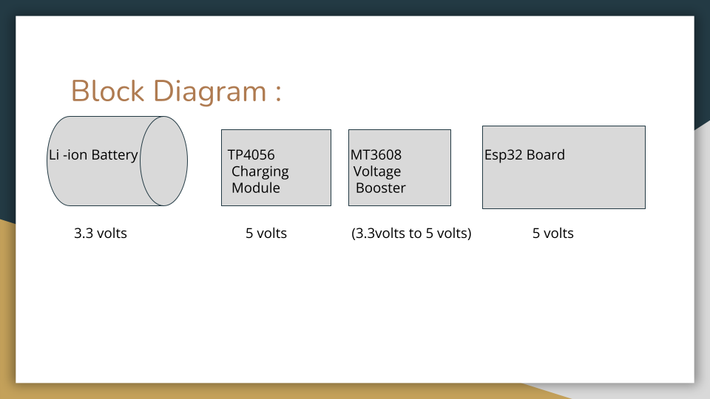

Swarm robotics methodology refers to the process of designing, implementing, and evaluating swarm robotics systems. The following are the key steps in the swarm robotics methodology:

1. Problem Identification: The first step is to identify the problem that the swarm robotics system is meant to solve. This involves defining the task to be performed, specifying the environmental constraints, and determining the desired performance metrics.
2. System Design: The next step is to design the swarm robotics system. This involves determining the number and type of robots required, selecting the appropriate sensors and actuators, and designing the communication and control algorithms.
3. Simulation and Testing: Before deploying the swarm robotics system in the real world, it is important to test it in simulation. This allows for the evaluation of the system's performance under different scenarios and for the tuning of the control algorithms.
4. Implementation: Once the swarm robotics system has been tested in simulation, it can be implemented in the real world. This involves deploying the robots, setting up the communication infrastructure, and executing the control algorithms.
5. Evaluation: The final step is to evaluate the performance of the swarm robotics system. This involves collecting data on the system's behavior and performance, analyzing the data to determine the system's strengths and weaknesses, and using this information to improve the system.

Overall, the swarm robotics methodology involves an iterative process of problem identification, system design, simulation and testing, implementation, and evaluation. By following this methodology, researchers and engineers can develop effective and efficient swarm robotics systems that can perform complex tasks in challenging environments.

## Chapter 4

**Hardware Connection**

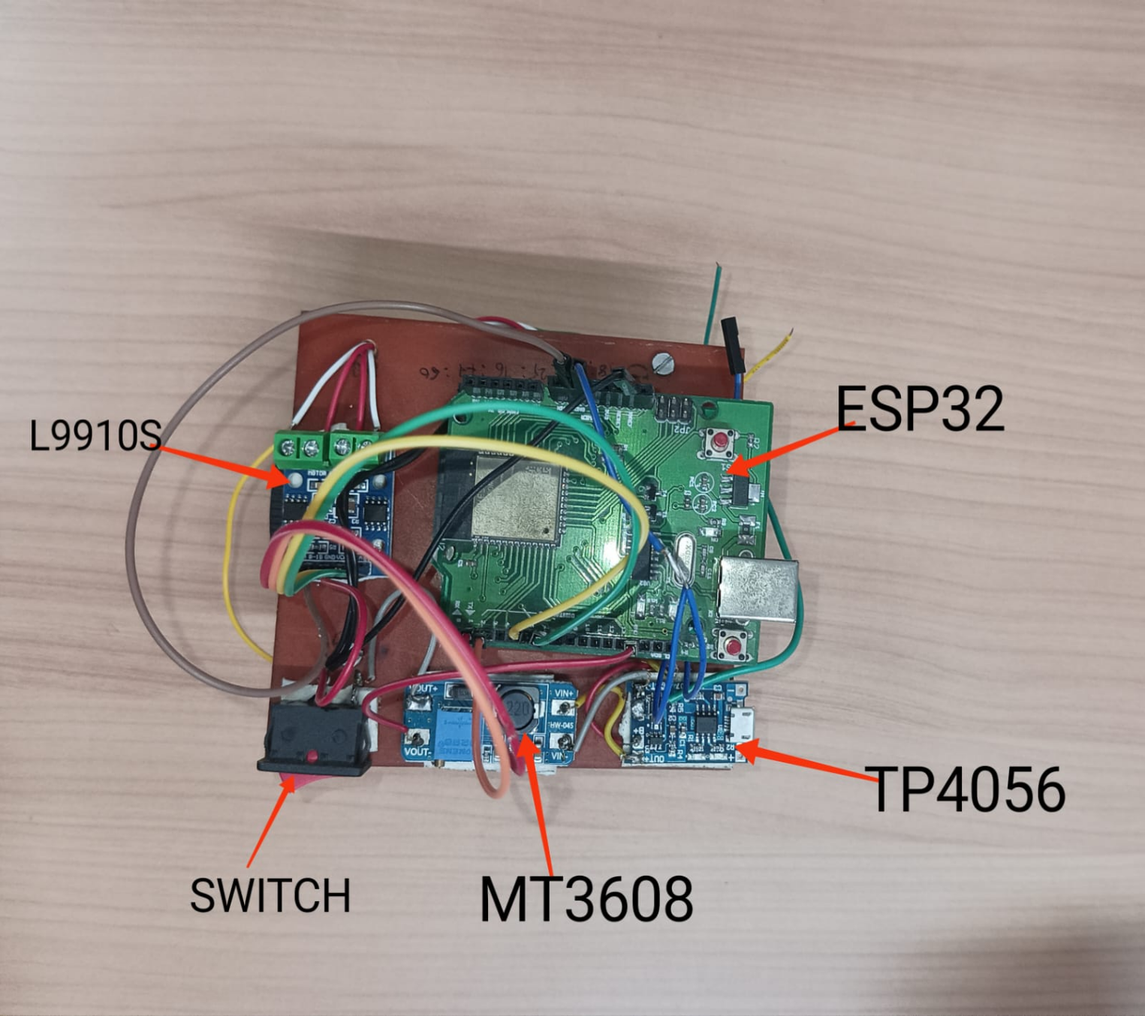

**1.Voltage Booster For providing Required Demand :**

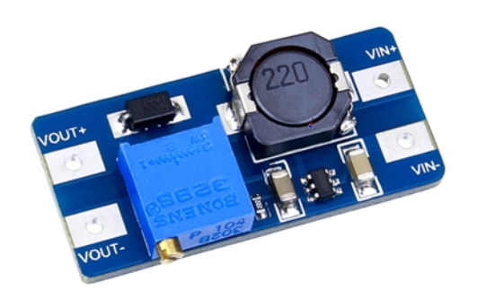

**Specifications :**

1. Input Voltage (V) : 2 ~ 24

2. Output Voltage(V) : 5 ~ 28

3. Output Current(A) : 2A

4. It's efficient by up to 93%.

5. It can source a good amount of current.

6. It is an inexpensive converter module.

7.Its simple to adjust to get your desired increase in voltage.

**2.TP4056 Charging Module For charging the LI-ION Battery**

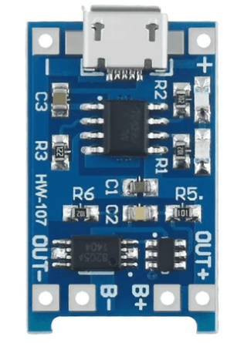

**Specifications :**

1.Input voltage: 4.5V-5.5V.

2. Current: 1A adjustable

3. Full charge voltage: 4.2Vull c

4.Led indicator: red is charging Green is fully charged.

5.Current Protection: Yes

6.Inverted polarity: NO.

**3. L9910S Motor Driver**

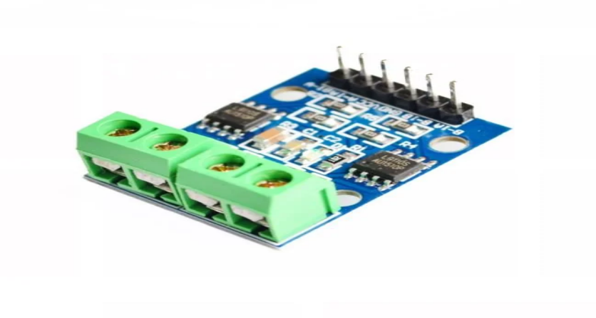

**Specifications :**

1. L9110S-chip motor drive
2. Supply voltage: 2.5-12V
3. The maximum operating current of 0.8A
4. Drive two DC motors or a 4-wire 2-phase stepping motor.
5. Ultra-small size, suitable for assembly

**4. Lithium Ion 3.7 volt Battery**

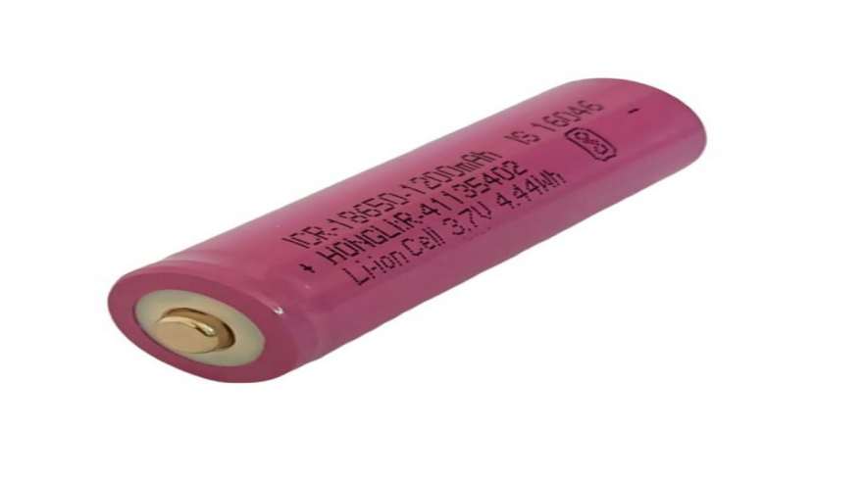

**Working Of the Hardware :**

First thing In the Hardware Execution is Checking all the components working very well. SO , First we have Checked All the components and we Have found problems in some of them , so we have calibrated those components and then Used further . So , The biggest problem is the voltage and the current Regulation in the system which we Have solved using the Voltage Booster MT3608 Module Which Supplies Constant 5 volt Which is Required For the Proper Regulation Of the System . So the Li-Ion battery gives us the 3.7 volt supply But Esp 32 Board Requires 5 volt constant supply . So , Through the Battery it is given to the Booster which Boosts The voltage upto 5 volts . So , The supply is further given to the Two motors and then the Robots works properly .

**Program & Execution**

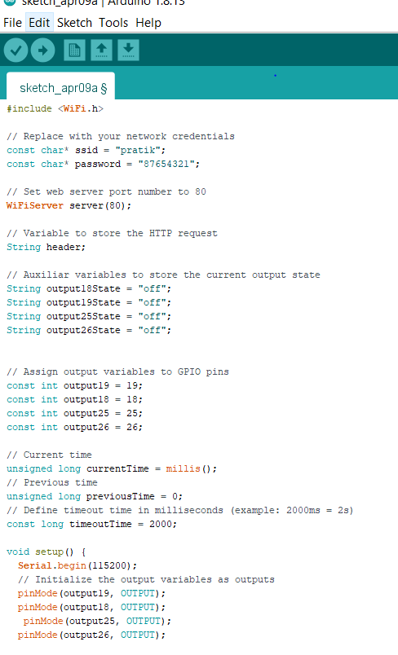

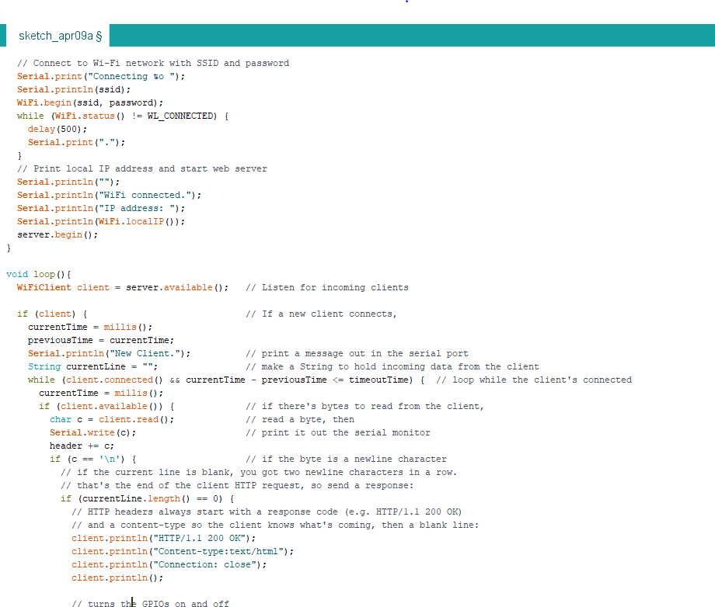

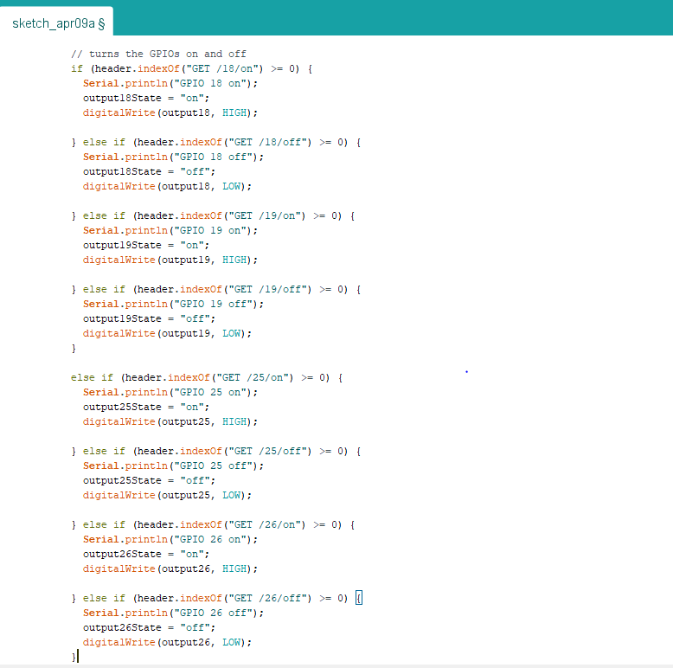

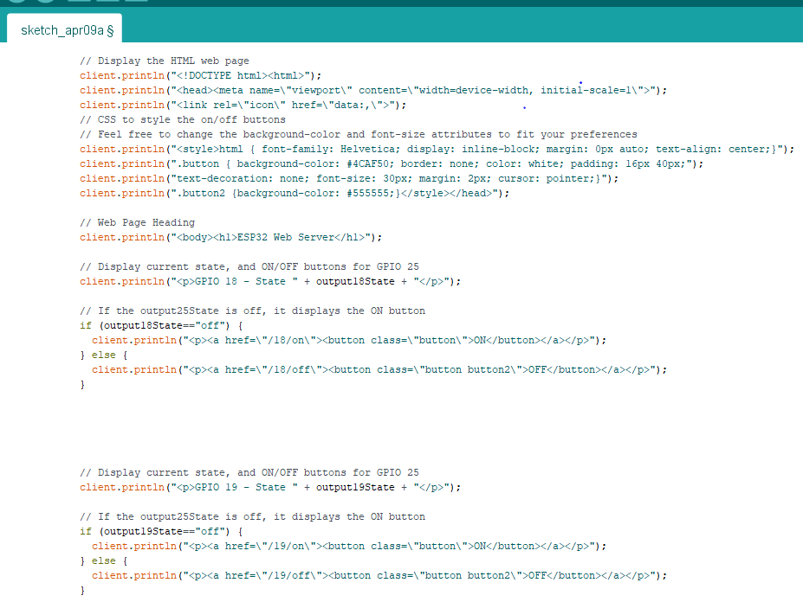

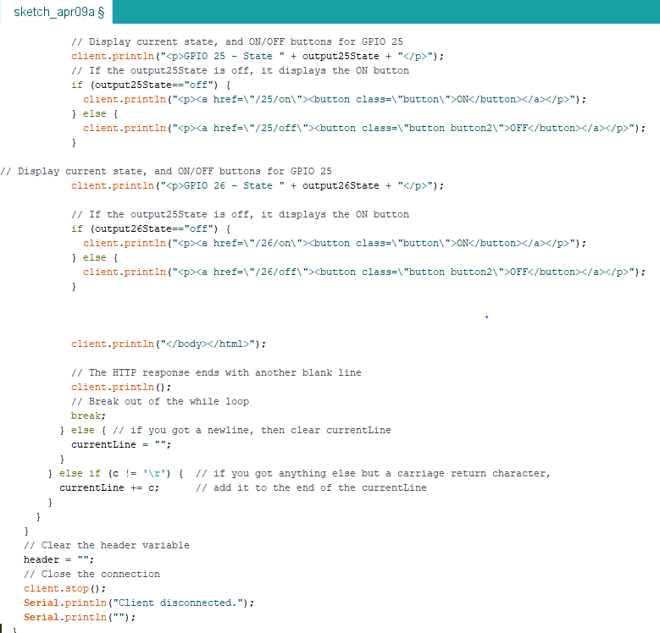

**WIFI Based Server :**

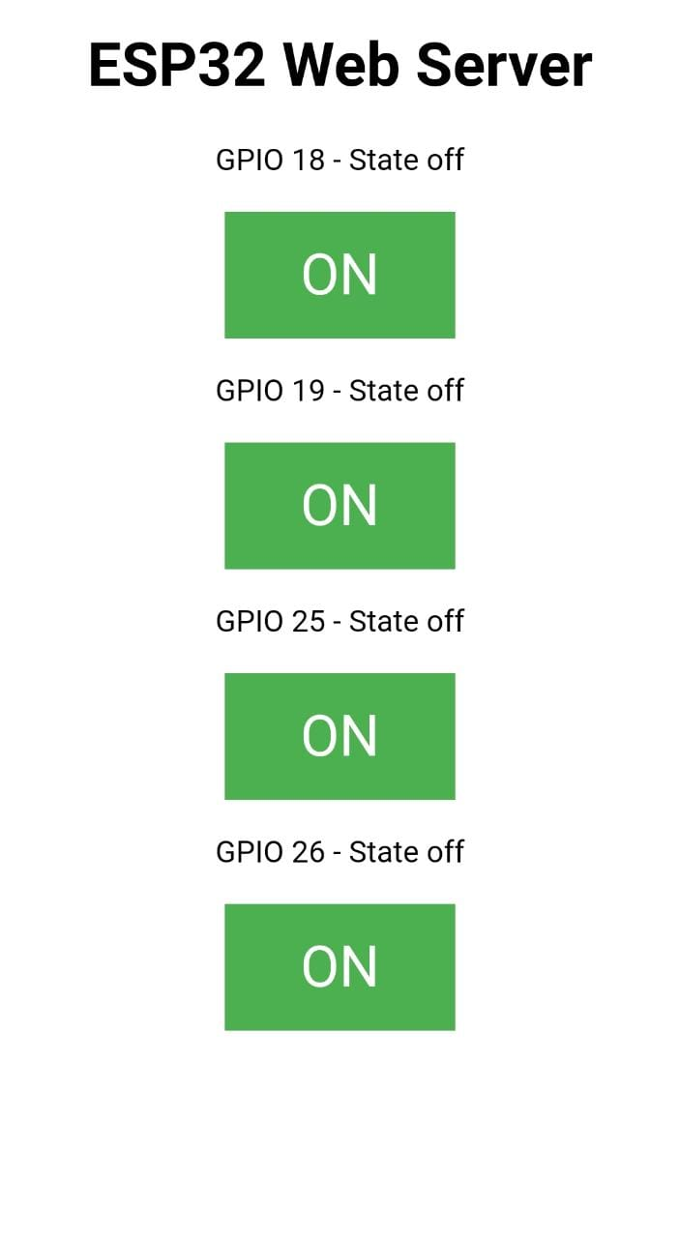

# Chapter 5

### Proposed execution

**5.1 Getting The Mac Address Of the Robots**

In this We Have tried to communicate using two robots using their MAC ADDRESS as their communication medium as WIFI . In that one is the sender and the other is the receiver which sends the data to the receiver .

To send messages between each board, we need to know [their MAC address](https://randomnerdtutorials.com/get-change-esp32-esp8266-mac-address-arduino/). Each board has a unique MAC address (learn how to [Get and Change the ESP32 MAC Address](https://randomnerdtutorials.com/get-change-esp32-esp8266-mac-address-arduino/)).

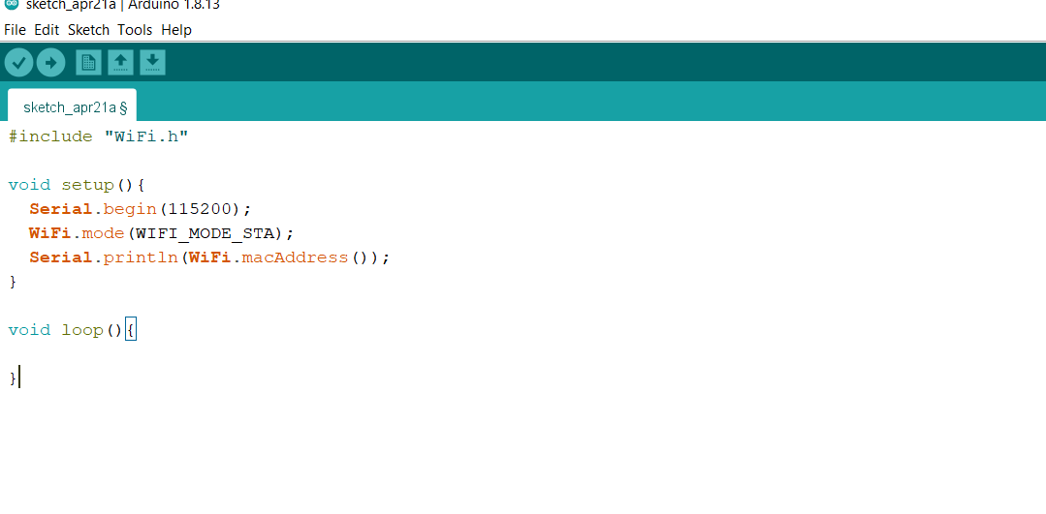

**Mac Address for Both the Boards :**

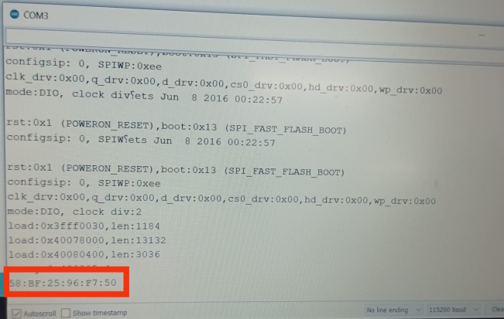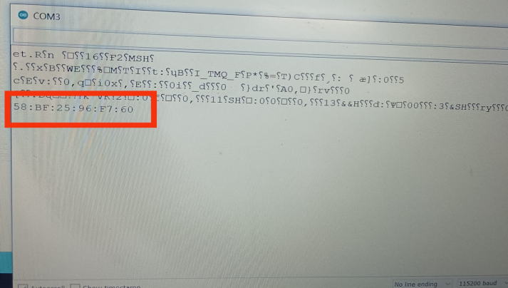

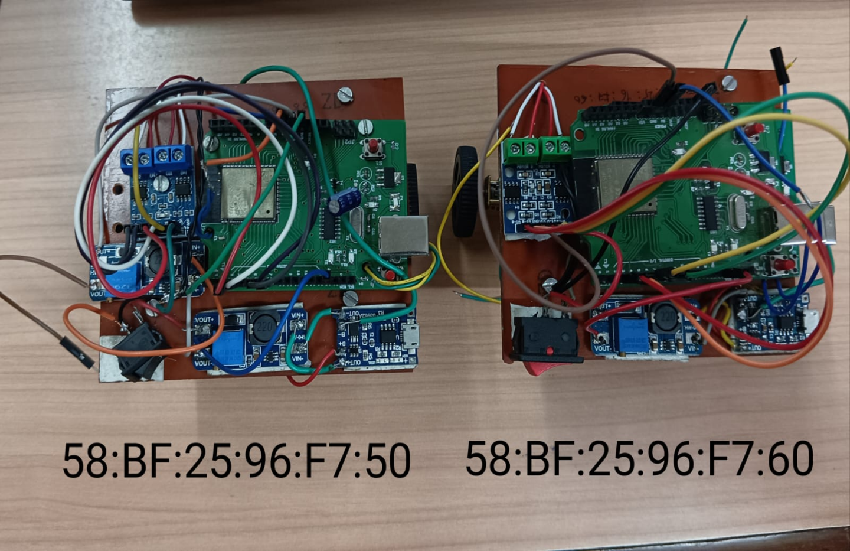

So , further using this Mac Address we are connecting the Two robots accessing through the wifi . with this we can

#### 5.2Communication between two robots

#### 

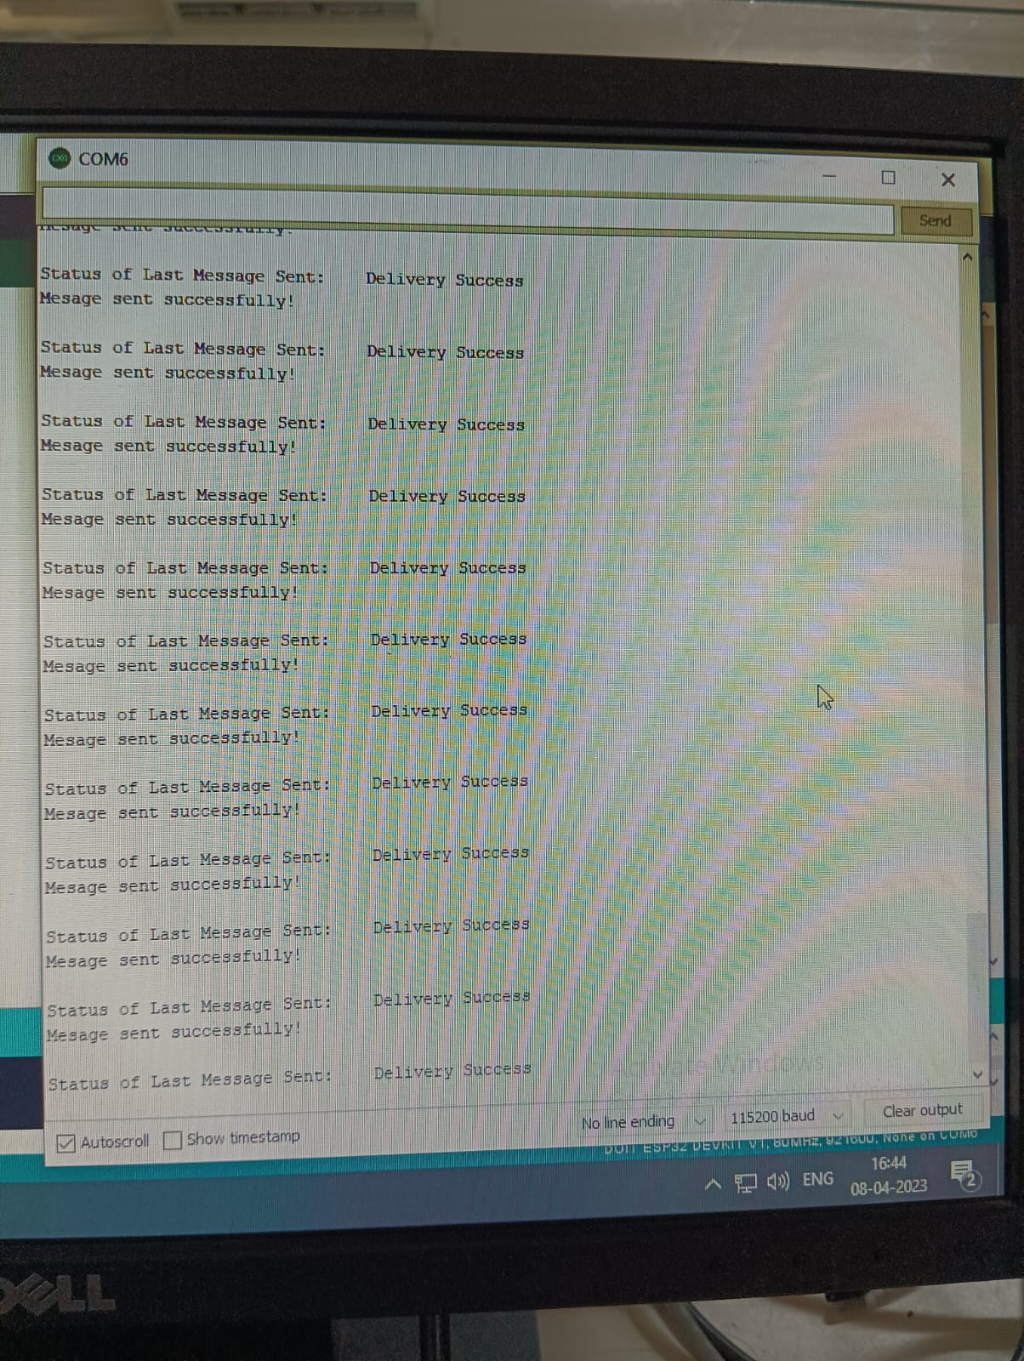

# CHAPTER 6

#### Results:

In this project, we used a swarm of robots that worked together to complete a task. The robot swarm successfully completed the task and proved that it is possible to use a swarm of robots to complete a challenging task. The robots were programmed to communicate with each other and share information, such as the location of obstacles and the status of the mission. They were also programmed to move in a coordinated manner to avoid collisions and perform the task quickly.

Both a simulated environment and an actual environment were used to evaluate the robot swarm. The robots performed the task effectively and avoided colliding with one another in the simulated environment. In the actual setting, the robots were able to complete the mission, although they ran into some communication and obstacle detection problems. The hardware and software of the robot were modified to fix these problems.

The robot swarm functioned admirably both in simulated and actual conditions. The research showcased the potential of this technology in a variety of applications, including search and rescue, environmental monitoring, and industrial automation. It also showed how crucial communication and coordination are in swarm robotics. The findings of this experiment point to swarm robotics as a promising area that has the potential to significantly influence a variety of businesses and applications.

#### 

#### 

#### 6.2 Conclusion:

In conclusion, swarm robotics is an exciting and rapidly growing field that offers many potential advantages over traditional robotics. The study of swarm robots involves the behavior of large groups of simple robots working together in a coordinated manner to achieve a common goal. Swarm robots are typically small, simple, and inexpensive, and can be used in a wide range of applications, such as search and rescue, environmental monitoring, and industrial automation.

Swarm robotics also offers potential advantages in terms of efficiency and robustness. The use of distributed control algorithms allows swarm robots to make decisions quickly and autonomously, without the need for centralized coordination. This can result in faster and more efficient operations. Additionally, the distributed nature of swarm robots allows them to be more robust and fault-tolerant than traditional robots, since failures in one part of the system do not necessarily affect the rest of the system.

Despite the potential advantages of swarm robotics, there are also many challenges that need to be addressed. One of the main challenges is developing effective control algorithms that allow the swarm robots to work together in a coordinated manner. Additionally, communication between the robots can be a challenge, especially in environments with obstacles or interference. Finally, power management is also a critical consideration, as swarm robots typically rely on batteries or other limited sources of energy.

Overall, the study of swarm robotics is an exciting and promising area of research that has the potential to revolutionize the field of robotics. As such, study of swarm robotics is likely to remain an important area of research for many years to come.

**Appendix**

* Pin configuration of ESP 32 BOARD :

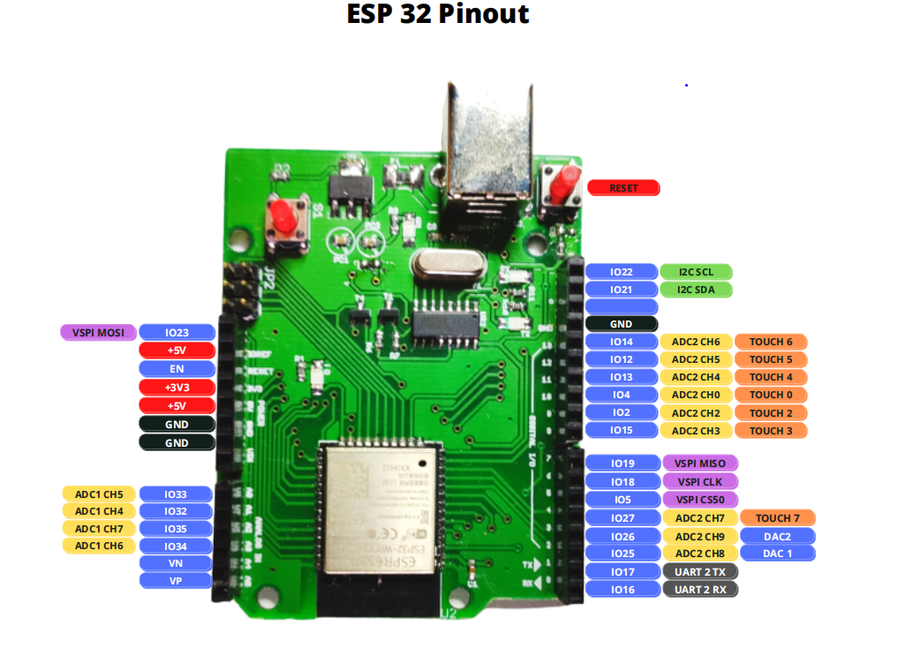

* TP4056 Charging Module :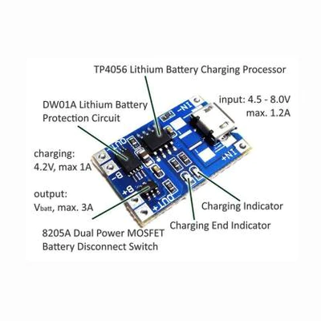

## REFERENCE

1. Bonabeau, E., Dorigo, M., & Theraulaz, G. (1999). Swarm Intelligence: From Natural to Artificial Systems. Oxford University Press.
2. Brutschy, A., & Dorigo, M. (2014). Swarm Robotics: A Formal Approach. In Handbook of Robotics (pp. 1437-1460). Springer.
3. Correll, N., & Martinoli, A. (2013). Swarm robotics. IEEE Robotics & Automation Magazine, 20(4), 60-71.
4. Dorigo, M., & Sahin, E. (2004). Swarm robotics: From sources of inspiration to domains of application. In Robotics and Cognitive Approaches to Spatial Mapping (pp. 1-9). Springer.
5. Groß, R., & Dorigo, M. (2008). Towards group transport by swarms of robots. Robotics and Autonomous Systems, 56(11), 941-955.
6. Hamann, H. (2018). Swarm Robotics: A Formal Definition and a Comprehensive Taxonomy. Frontiers in Robotics and AI, 5, 75.
7. Kennedy, J., & Eberhart, R. (1995). Particle swarm optimization. In Proceedings of IEEE International Conference on Neural Networks (pp. 1942-1948). IEEE.
8. Nguyen, T. H., Nguyen, T. H., & Yang, H. J. (2014). Swarm robotics: a review of swarm intelligence approaches and applications. International Journal of Control and Automation, 7(3), 27-34.
9. Sahin, E. (2005). Swarm robotics: From concept to reality. In Swarm Robotics (pp. 1-9). Springer.
10. Trianni, V., & Dorigo, M. (2013). Evolving aggregation behaviors in a swarm of robots. PLoS ONE,

## Acknowledgement

“It is not possible to prepare a project without the assistance and encouragement of other people. This one is certainly no exception.

We express our gratitude to everyone who supported us throughout the course of this project. We are thankful for their aspiring guidance and friendly advice during the project work. We are sincerely grateful to them for sharing their truthful and illuminating views on a number of issues related to the project.

We would like to express our deep sense of gratitude to our respected and learned guide Ast. prof. N. Gopalkrishnan for their valuable help and guidance. We are thankful to them for the encouragement they have given us in completing the project.

We are grateful to prof. Mrs. Sangeeta Prasanna Ram HOD (INST) for permitting us to utilize all the necessary facilities of the institution. We are also thankful to all the other faculty and staff members of our department for their kind cooperation and help.

Thank you

Pratik Waghmode 67

Sanskar Halpati 17

Vedant Hatte 18

Ishan Udgirkar 60